Urban Heat Island in Kathmandu, Nepal: Evaluating Relationship between NDVI and LST from 2000 to 2016

Bijesh Mishra1, 2, Jeremy Sandifer2, and Buddhi Gyawali2

Department of Natural Resource Ecology and Management, Oklahoma State University, Stillwater, USA, 740751

College of Agriculture, Communities and the Environment, Kentucky State University, Frankfort, KY, 406012

Mr. Mishra was a Graduate Student at Kentucky State University when this research was conducted.

*Correspondence to*: Bijesh Mishra ([bijesh.mishra@okstate.edu](mailto:bijesh.mishra@okstate.edu)) *Buddhi Gyawali (*[*buddhi.gyawali@kysu.edu*](mailto:buddhi.gyawali@kysu.edu))

**Abstract:** The term “urban heat island” (UHI) describes the increased surface and atmospheric temperatures in an urban core relative to surrounding non-urbanized areas. Although the phenomenon has been studied to a great extent throughout the world, it is less understood for Kathmandu, Nepal. This study uses the Moderate Resolution Imaging Spectro-radiometer (MODIS) 8-day product (MOD11A2) to evaluate land surface temperatures (LSTs), the MODIS-derived Normalized Difference Vegetation Index (NDVI) product (MOD13Q1) to quantify land surface characteristics, and the MODIS annual land cover classification product (MCD12Q1) to identify major land cover classes We evaluated the spatial correlation between significant changes in LSTs and NDVI between 2000–2016 during the month of May. Overall, urban LSTs were consistently greater than non-urban LSTs; however, the rate of increase in temperature was higher outside the urban area. Furthermore, significant changes in NDVI values over time were more widespread and not spatially coincident with the significant changes in LST values. These results provide insight into systematic planning of open and green areas, construction of new infrastructure in peripheral areas, as well as highlight the challenges in applying traditional UHI methods to rapidly developing urban areas in Kathmandu, Nepal.

# 1 Introduction

Urbanization in Nepal has been observed since 1970 (Rimal et al. 2017; Thapa et al., 2008). In last couple of decades, Nepal has been among those countries with the highest urbanization rates with an annual increase of 3.0 %. This trend is expected continue until 2050 (Bakrania, 2015; UN DESA, 2015). The areas with the greatest urbanization rates were in the Kathmandu Valley (MoUD, 2015; Thapa et al., 2008), which comprises 24.02% of the total urban area. Kathmandu’s metropolitan municipality contains approximately 9.72 % of the valley’s total urban population (Bakrania, 2015; MoUD, 2015). Kathmandu is a major urban center with a population exceeding three million people (Chitrakar et al., 2016).

The climatic and weather conditions of the Kathmandu Valley have changed tremendously over last few decades because of rapid urbanization and the conversion of a valley dominated by agroforestry practices into an impervious surface layer. It has become uncomfortable, vulnerable, and unhealthy for living as well as vulnerable and susceptible to the diseases outbreaks (Maharjan and Regmi, 2014). The temperature and relative humidity are both higher in Kathmandu city (which consists of only Kathmandu Metropolitan City area) and nearby surrounding area, compared to the surrounding valley (includes Kathmndu, Bhaktapur and Lalitpur districts) and nearby locations throughout the year (Maharjan and Regmi, 2014; MoUD, 2015).

Kathmandu Valley’s land use and land cover has changed significantly in the last four decades. Rimal et al. (2017) found that Kathmandu Valley had an average annual urban growth rate of 7.34 % between 1976 and 1989, 7.70 % between 1989 and 2002, and 5.90 % between 2002 and 2015. Ishtiaque et al. (2017) found that the city has expanded as much as 412 %, with the majority of land converted from agricultural land, which has changed the valley’s landscape.

The urbanization process reduces greenery and increases the number of impervious surfaces. This process causes changes in land use, land cover, and land surface characteristics that subsequently modify the local climate moisture exchange and ecosystem services, favoring heat trapping and storage (Cui et al., 2016; Jin et al., 2005; Lavaysse et al., 2018; Li et al., 2009). Heat trapping leads to temperature differences between urban and surrounding rural areas, with temperatures in the urban area temperatures higher than in rural areas, a phenomenon known as an “urban heat island” (UHI) (Jin et al., 2005; Li et al. 2009). Increasing the population within these urban areas exacerbates the UHI effects as well as exposes more people to the potential risks of UHI, such as hyperthermia (Azevedo et al., 2016).

The UHI phenomenon is important to study because it affects many aspects of life, such as infrastructure, health, energy consumption, environmental stress, and discomfort, and leads to additional costs in building infrastructure (Azevedo et al., 2016). New studies show that, depending on the nature and developmental phase, UHI can have detrimental socio-economic effects (Cui et. al., 2016). Although some studies about changes in temperature have been conducted in the Kathmandu Valley, none of these studies have examined closely the UHI phenomenon and its relationship to other possible factors. Land surface temperature (LST) is an important factor in UHI (Zakšek and Oštir, 2012). Various studies found a correlation between the Normalized Difference Vegetation Index (NDVI) and LST (Grover and Singh, 2015; Liu et al., 2015). This correlation, however, may vary based on differences in topography, demographics, and land cover attributes. Our study focuses on two major research questions: 1) Was there a significant change in the monthly LSTs of the Kathmandu Valley from 2000–2016? and 2) Was the LST change associated with the NDVI change?

# 2 Material and Method

## 2.1 Study site

Kathmandu Valley, as shown in Fig. 1, is located at the latitude and longitude of 27°38’32”-27°45’7” N and 85°16’5”-85°22’32” E (Thapa et al., 2008). The bowl-shaped valley has an elevation of 1,100–2,700 m (average 1,350 m) above mean sea level (Chitrakar et al., 2016; Thapa et al., 2008; Thapa and Murayama, 2009). The valley is subdivided into five neighboring urban areas (Kathmandu, Bhaktapur, Lalitpur, Kirtipur, and Madhyapur Thimi) and 97 surrounding peri-urban and rural villages based on administrative units (Ishtiaque et al., 2017; Thapa and Murayama, 2012). The Kathmandu Metropolitan City area is flat with less than 1° slope and the soil is predominantly loamy and boulder in texture (Haack and Khatiwada, 2007; Thapa et al., 2008).

**<Figure 1>**

## 2.2 Data Collection

This study made extensive use of the Moderate Resolution Imaging Spectro-radiometer (MODIS) instruments because of its wide systemic geographic coverage and relatively high temporal resolution. Utilized products include the 8-day LST 1 km product (MOD11A2), the 16-day NDVI 250 m product (MOD13Q1), and the annual land cover classification 500 m product (MCD12Q1). The 500 m MODIS imagery pixel centroids were used as the individual units of observation as well as for sampling of LST and NDVI data. The sampling extent was generated by converting the MODIS land cover product raster data into point-based centroids, where each centroid point retains the respective land cover types. Each centroid was sampled against all LST and NDVI layers and spatially resampled to match the 500-meter resolution of the land cover product using the cubic convolution algorithm. The extent was aimed at capturing LST variation in Kathmandu and adjacent areas within the valley. The points also covered a wide range of geographic conditions and elevation heights.

**<Figure 2>**

This study utilized the 500 m MODIS MCD12Q1 Collection 5 global land cover product (Didan, 2015) to estimate the total portion of land cover type (for example, forested, crop-land, or developed areas) within Kathmandu city and to delineate land areas according to the particular land cover types. These delineated areas were analyzed using the LST and NDVI data to give a sense of the range of values in the study area.

Sampling was conducted at the pixel level to quantify the distribution of change in LST and NDVI values in a spatially explicit manner not typically captured when aggregating values according to classifications or zones. Pixel-based calculations on each 8-day LST image layer and coincident 16-day NDVI image were implemented using the ArcPy package in Python and resulted in 8-day time series database tables covering the period March 2000 to December 2016. Each pixel time series was grouped according to month and evaluated using a simple linear model to test for any significant change in LST or NDVI values over time. The simple linear model was expressed as:

*Y = C + M β m + ɛ (1)*

where *M* is the length of time of each location’s (*m*) LST or NDVI value (*Y*); β is the slope, which equals the increase in *Y* per time step in *M*; *C* is the y-intercept constant; and *ɛ* is the error. The generated β coefficients described the approximate increase in LST and NDVI over time and any potentially significant change was based on *p*-values (*p* < 0.05). This analysis was applied to all of the pixels separately for each month (2000–2016). Data summaries were compiled to test hypotheses using R statistical packages (R Core Team, 2013).

# 3 Results and Discussion

## 3.1 Daytime surface temperature distribution of Kathmandu (MOD1152 500 m pixel)

One of the focuses of the research was to study the changes in LST from 2000-2016 in the Kathmandu Valley. These results validated several important findings: A) MODIS MOD11A2 500 m pixel imagery showed that the daytime temperature in Kathmandu Valley was higher than the surrounding area; (B) Kathmandu is the most urbanized part of the valley; therefore, it has more developed areas compared to its surroundings, which may be why the temperature is high; and (C) The highest temperature in Kathmandu Valley was in the developed land among three major types of land covers i.e. forest, agriculture and developed land. Figure 3 provides daytime surface temperature distribution of Kathmandu as determined by MODIS MOD11A2 500 m pixel imagery.

**<Figure 3>**

## 3.2 Monthly LST distribution over different land cover types

Figure 4 shows the distribution of monthly LST values for three important land cover classes (forests, crops, and built or developed land). Forested land (pink) is the coolest land cover type throughout the year followed by agricultural lands (green) and developed areas (blue). In addition, the LST is at its peak during the month of May, just before the onset of the monsoon season. The difference in LSTs gradually increases as summer approaches and is particularly variable during the monsoon months of June to September as shown by the large range of temperatures captured for those months (Fig. 4). May is one of the hottest months in Nepal and it follows that any increase in urban areas will result in increased LSTs during this time of year.

**<Figure 4>**

The overall biggest potential temperature difference between different land cover types is highest in the month of July. The temperature difference between different land cover types is relatively small during the winter months and presumably would be less affected by the physical changes to the landscape in terms of the LST increase. In addition, the temperature differences among various land cover types are relatively small during winter compared to the summer season, which suggests that heat trapping is also high during summer months.

The newly developed region with the highest temperature is in the west of Kathmandu, where areas of new settlement have been expanding and large areas of forestland are being converted into agricultural land and agricultural land is being converted into urban areas (Ishtiaque et al., 2017; Thapa and Murayama, 2009; Thapa and Murayama, 2012). The center of the Kathmandu Valley is also the most populated region of the valley. However, the population growth is very high in surrounding semi-urban areas (Ishtiaque et. al., 2017). The future trend of the surface temperature is projectable based on the trends of population changes in the Kathmandu Valley. It is more likely that the current temperature of the core city is going to be the temperature of the surrounding semi-urban areas of Kathmandu in the future if this trend continue.

## 3.3 Change in LST and NDVI over time

The LST change over time from 2000–2016 was calculated for each pixel throughout the study area using the simple linear model described in Eq. (1), where the generated beta coefficient acts as estimate for the increase in LST values per each time step. The change in LST over from 2000-2016 for the month of May is displayed in figure 5 and highlights each area where LSTs have significantly increased or decreased (*p* < 0.05). In this figure, areas colored red represent a relative annual increase of 0.25° C–2° C and areas colored blue represents an annual decrease of 0.5° C–2.5° C. However, only black dots represent significant changes in temperature from 2000-2016.

**<Figure 5> <Figure 6>**

The map in fig. 5 show that the temperature has significantly changed in areas outside the core of Kathmandu City and in those areas where new urban and semi-urban areas are expanding. For example, in the Northeast portion of the image, there is a large clustering of pixels indicating significant changes in temperature, however, confined on small location and not widespread. There are several areas within the Kathmandu City that has significant increases in LSTs, although it is relatively small compared to peripheral areas. Overall, the LST in May changed significantly outside the urban Kathmandu Valley.

The NDVI change from 2000-2016 was calculated for each pixel throughout the study area using the simple linear model described in Eq. (1), where the generated beta coefficient acts as estimate for the increase in NDVI values per each time step. The change in NDVI from 2000-2016 for the month of May is displayed in Fig. 6 and it highlights areas where NDVI values have increased or decreased significantly.

Figure 6 shows the change in NDVI from 2000–2016 is well distributed throughout the study area. The figure clearly illustrates the widespread decrease in NDVI values in most of the central valley, especially just north of the administrative areas of Kathmandu and Bhaktapur districts. In contrast, many peripheral areas have experienced significant increases in NDVI values, especially in the northwest and south central portion of the delineated study area. In each case, these findings were expected as previously reported (Ishtiaque et al., 2017).

Changes in the LST and in the NDVI were not spatially correlated. This lack of correlation was surprising since several articles found that NDVI is highly correlated with LST (Grover and Singh, 2015; Liu et al., 2015). Although LST is high in developed areas of the Kathmandu Valley, the rate of LST change is stable. The LST rate changes significantly outside Kathmandu Valley. However, the NDVI has changed significantly in the Kathmandu Valley. The significant change in NDVI is not as dense as it was observed inside the valley. We found that the highest changes were in Kathmandu Valley’s core-developed region, which extends to the city. This distribution pattern does not show the interrelationship between these parameters. Thus, the findings of the current research contrast with previous findings in terms of significant change in LSTs and NDVI and the spatial distribution of the LST and NDVI. However, the result supports the finding of recent researches conducted in cities in same stage of development.

Cui et al. (2016) conducted similar research and found that UHI shows global heterogeneity for several reasons, including the location’s geography and socioeconomic conditions. The research also showed that the socioeconomic factors and population dynamics play important roles in determining UHI in developing countries, whereas GDP plays a major role in UHI formation and its effects in developed countries. This is because the impact of socioeconomic factors, such as population and gross domestic product (GDP), on the UHI are greater during early stages of an urban development process has not been linear and is complex to model for the type of analysis presented here. Specifically, general population characteristics are the main impact factor in land cover change and consequent development of increased surface UHI intensity in rapidly developing urban areas, such as in parts of China, whereas nationally aggregated GDP variation was the main impact factor in a developed country like the United States. This difference highlights the need for modelling efforts to incorporate additional information characterizing the spatial dynamics of the population attached to that physical area. These factors should be taken into account when studying UHI and its hazardous effects in developing city such as Kathmandu and its peripheries.

# 4 Conclusions

We studied urban heat islands in Kathmandu using MODIS images. We used MODIS imagery standard products to analyze the spatial distribution of LST in the Kathmandu Valley and to correlate the NDVI so that we could study UHI temperature patterns. The city’s core had the highest temperature although the change in temperature was more significant in newly developing urban and semi-urban areas. The development of new urban and semi-urban centers will increase the temperature of the region further, and it has potential to expand health risks among urban population and ecosystems of the Kathmandu Valley in the future.

NDVI values also changed significantly in the Kathmandu Valley’s central core and outlying areas. The magnitude of change was high in the surrounding areas compared to the valley’s core. This suggests that the greenery inside the valley has decreased significantly over the past two decades, and the removal of vegetation is expanding towards the outer newly developed semi-urban areas. These newly developing semi-urban areas are likely to become new urban centers that may have many of the same characteristics as the valley’s core.

The spatial relation of change in LST and the NDVI was not significant. Additional research is needed to study UHI from other perspectives in addition to vegetation changes. NDVI data has validated UHI in several big cities (Grover and Singh, 2015; Liu et al., 2015); however, this is not true in the case of Kathmandu. Cui et al. (2016) found that geography and socioeconomic variations play important roles in determining UHI. They also found that population may also have an important role in UHI phenomenon during the early stages of urbanization. Our research findings are consistent with this finding, particularly with respect to Kathmandu in the developing phase. More studies are also needed combining NDVI, population, and socioeconomic attributes to understand coupled effects in UHI of Kathmandu Valley.

# Acknowledgement:

This research was funded by National Science Foundation Historically Black College and Universities-Undergraduate Program. (NSF_HBCU_UP “Promoting Minority Students Participation in STEM-Undergraduate Degree Program, HRD Award No. 1332477).

# References

Azevedo, J., Chapman, L., and Muller, C., 2016. Quantifying the daytime and night-time urban heat island in Birmingham, UK: A comparison of satellite derived land surface temperature and high resolution air temperature observations, Remote Sens, 8. doi:10.3390/rs8020153.

Bakrania, S., 2015. Urbanization and urban growth in Nepal, GRDC Helpdesk Research Report 1294, Birmingham, UK: GSDRC, University of Birmingham.

Chitrakar, R. M., Baker D. C., and Guaralda, M., 2016. Urban growth and development of contemporary neighborhood public space in Kathmandu Valley, Nepal. Habitat Int., 53, 30-38, doi:10.1016/j.habitatint.2015.11.006.

Cui, Y., Xu, X., Dong, J., and Qin, Y., 2016. Influence of urbanization factors on surface urban heat island intensity: A comparison of countries at different developmental phases. Sustainability, 8. doi:10.3390/su8080706.

Didan, K., 2015. MOD13Q1 MODIS/Terra Vegetation Indices 16 Day L3 Global 250 m SIN Grid V006, NASA EOSDIS Land Processes DAAC, <https://doi.org/10.5067/MODIS/MOD13Q1.006>.

Grover A., and Singh, R. B., 2015. Analysis of urban heat island (UHI) in relation to normalized difference vegetation index (NDVI): A comparative study of Delhi and Mumbai, Environments, 2 (2), 125-138, doi:10.3390/environments2020125.

Haack, B. N., and Khatiwada, G., 2007. Rice and bricks: Environmental issues and mapping of the unusual crop rotation pattern in the Kathmandu Valley, Nepal, Environ. Manage. , 39, 774-782, doi:10.1007/s00267-006-0167-0.

Ishtiaque A, Shrestha M., and Chhetri N., 2017. Rapid urban growth in the Kathmandu Valley Nepal: Monitoring land use land cover dynamics of a Himalayan City with Landsat Imageries, Environments, 4 (72). <http://dx.doi.org/10.3390/environments4040072>.

Jin, M., Dickinson, R. E., and Zhang, D., 2005. The footprint of urban areas on global climate as characterized by MODIS, J Climate, 18, 1551-1565, doi:10.1175/jcli3334.1.

Lavaysse, C., Cammalleri, C., Dosio, A., Schrier, G. V.D., Toreti, A., and Vogt, J., 2018. Towards a monitoring system of temperature extremes in Europe. Nat. Hazards Earth Syst. Sci. 18, 91-104.

Li, J.J.; Wang, X.R.; Wang, X.J.; Ma, W.C.; Zhang, H., 2009. Remote sensing evaluation of urban heat island and its spatial pattern of the Shanghai metropolitan area, China. Ecol. Complex, 6, 413-420. https://doi.org/10.1016/j.ecocom.2009.02.002.

Liu, W., Ji, C. Jiang, X., and Zhong, J., 2015. Relationship between NDVI and the urban heat island effect in Beijing area of China, SIPE Proceedings Vol 5884, Remote Sensing and Modeling of Ecosystem for Sustainability II, Editors: Gao and Shaw.

Maharjan, S., and Regmi, R.P., 2014. Grid based temperature and relative humidity distribution map of the Kathmandu Valley, J Inst Sci Technol, 19, 7-13, doi:10.3126/jist.v19i1.13819.

Ministry of Urban Development (MoUD), 2015. National Urban Development Strategy. Ministry of Urban Development, Government of Nepal, available at: <http://moud.gov.np/wp-content/uploads/2016/08/NUDS-2015-final-draft.pdf>, last accessed 21 February 2017, 2015.

R Core Team. R, 2013. A language and environment for statistical computing, R Foundation for Statistical Computing, Vienna, Austria, available at: <http://www.R-project.org/>, last accessed 11 October 2017.

Rimal B., Zhang L., Dongjie O., Kunwar R., Zhai, Y., 2017. Moonitoring urban growth and the Nepal earthquake 2015 for sustainability of Kathmandu Valley, Nepal, Land 6 (2) 42; doi:[10.3390/land6020042](http://dx.doi.org/10.3390/land6020042). <http://www.mdpi.com/2073-445X/6/2/42/htm>.

Thapa, R. B., Murayama, Y., and Ale, S., 2008. City profile Kathmandu. Cities, 25, 45-57. doi:10.1016/j.cities.2007.10.001.

Thapa, R. B., and Murayama, Y., 2009. Examining spatiotemporal urbanization patterns in Kathmandu Valley, Nepal: Remote sensing and spatial metrics approaches, Remote Sens., 1, 534-556. doi:10.3390/rs1030534.

Thapa, R. B., and Murayama Y., 2012. Scenario based urban growth allocation in Kathmandu Valley, Nepal, Landscape Urban Plan, 105, 140-148, doi:10.1016/j.landurbplan.2011.12.007.

United Nations, Department of Economic and Social Affairs (UN DESA), 2015. World Urbanization Prospects: The 2014 Revisions, (ST/ESA/SER.A/366), available at: <https://esa.un.org/Unpd/Wup/Publications/Files/WUP2014-Report.pdf>, last accessed 20 February 2017.

Zakšek, K., and Oštir, K., 2012. Downscaling land surface temperature for urban heat island diurnal cycle analysis. Remote Sens. Environ, 117, 114-124, doi:10.1016/j.rse.2011.05.02.

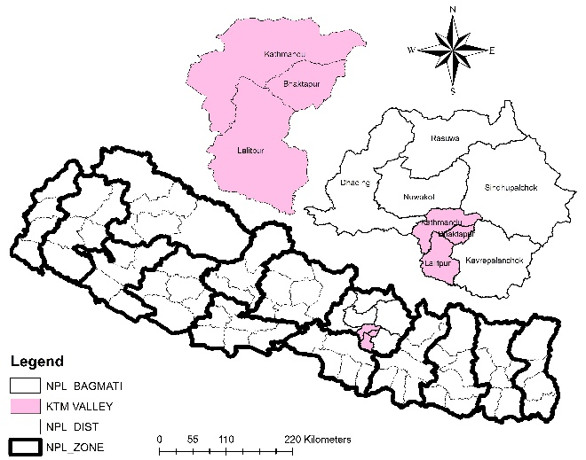**Figure 1: The Kathmandu Valley, Nepal.**

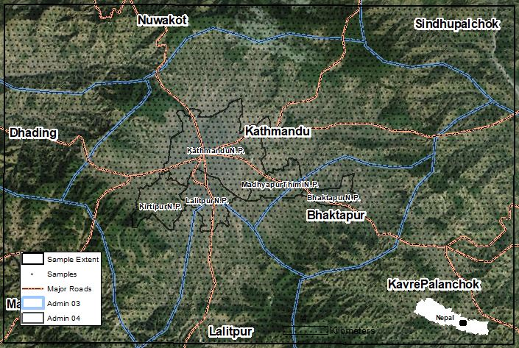Figure 2: Sampling extent in the study area. MODIS-500 meter centroid observation units (N = 6029)

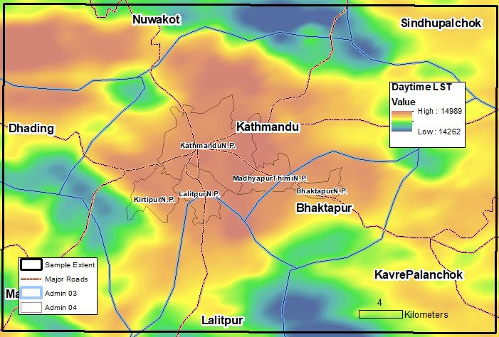Figure 3: Daytime surface temperature distribution of Kathmandu driven largely by land cover and elevation (MOD11A2 on 10 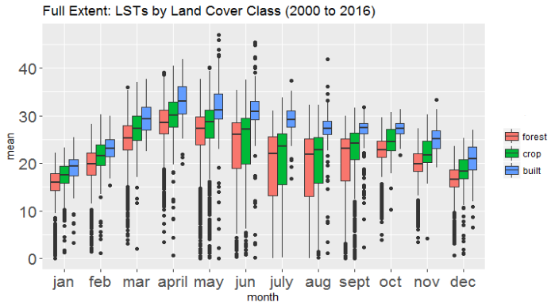October 2013)

Figure 4: Full extent of Monthly LST by land cover class (2000-2016)

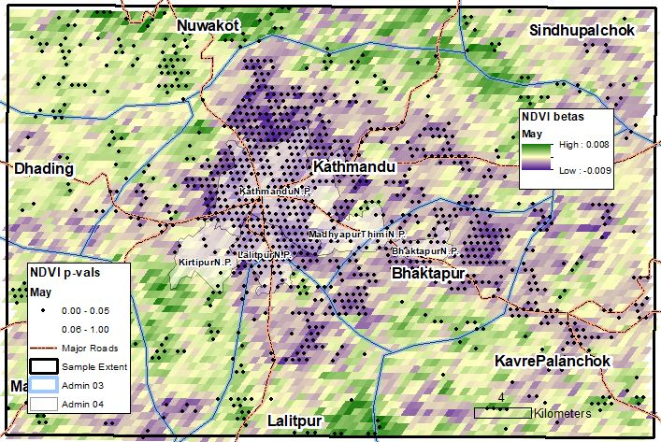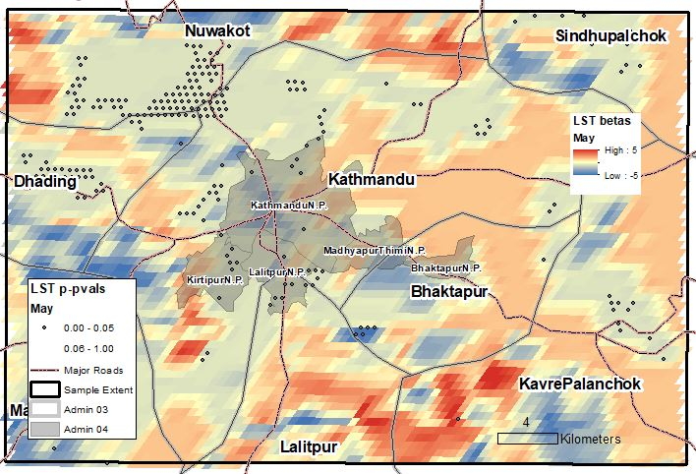Figure 5: The change in LST from 2000-2016 for the month of May.

Figure 6: The change in monthly NDVI from 2000-2016. Black dots represents significant change in NDVI values.